Tiya Farah

5/16/2022

Foundations of Programming: Python

**Assignment 5: Creating a To Do List**

**Introduction**

For this assignment, I will demonstrate how to work with lists, dictionaries, and files and making an application that will manage data.

**Drafting the Code**

I started by using the code provided by the instructor in module 05 files. I began by copying the data provided. My task consisted of opening and writing data into the file and filling in the required sections. ( see example. 1)

Example. #1

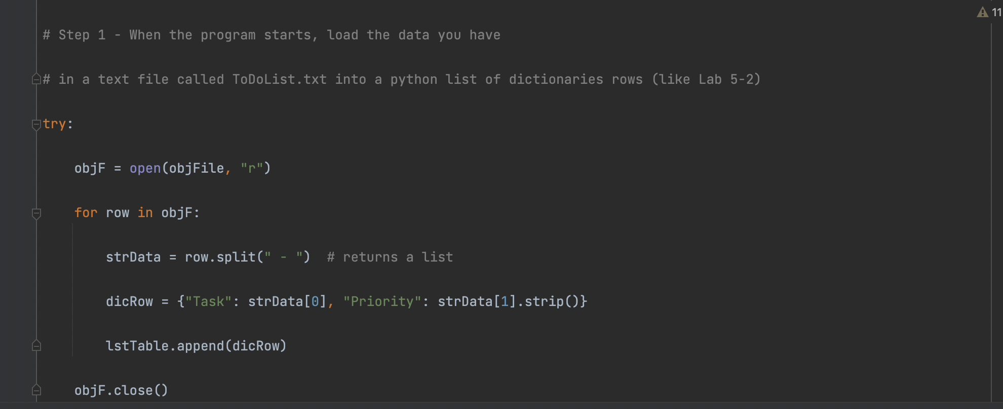

**Step by Step Guide**

Step #1: I opened the Pycharm tool on my MacBook and began writing code under Assignment05 .py (see ex. 1)

Ex. 1

# -- Data -- #

# declare variables and constants

objFile = "ToDoList.txt" # An object that represents a file

objF = None # File handle

strData = "" # A row of text data from the file

dicRow = {} # A row of data separated into elements of a dictionary {Task,Priority}

lstTable = [] # A list that acts as a 'table' of rows

strMenu = "" # A menu of user options

strChoice = "" # A Capture the user option selection

strTask = "" # New task entry from the user

strPriority = "" # New priority entry from the user

strRemove = "" # A task to be removed

# -- Processing -- #

# Step 1 - When the program starts, load the data you have

# in a text file called ToDoList.txt into a python list of dictionaries rows (like Lab 5-2)

try:

objF = open(objFile, "r")

for row in objF:

strData = row.split(" - ") # returns a list

dicRow = {"Task": strData[0], "Priority": strData[1].strip()}

lstTable.append(dicRow)

objF.close()

except:

print('File not found, new file will be created, when you save.')

# -- Input/Output -- #

# Step 2 - Display a menu of choices to the user

while (True):

print("""

Menu of Options

1) Show current data

2) Add a new item.

3) Remove an existing item.

4) Save Data to File

5) Exit Program

""")

strChoice = str(input("Which option would you like to perform? [1 to 5] - "))

print() # adding a new line for looks

# Step 3 - Show the current items in the table

if (strChoice.strip() == '1'):

print('Current To Do List [Task - Priority]:')

for row in lstTable:

print(row["Task"], row["Priority"], sep=" - ")

continue

# Step 4 - Add a new item to the list/Table

elif (strChoice.strip() == '2'):

strTask = input("Please enter a task: ")

strPriority = input("Please give it a priority: ")

lstTable.append({"Task": strTask, "Priority": strPriority})

print("New Task has been added!")

continue

# Step 5 - Remove an item from the list/Table

elif (strChoice.strip() == '3'):

strRemove = input("Enter a task to remove: ")

for row in lstTable:

if row["Task"].lower() == strRemove.lower():

lstTable.remove(row)

print("The task has been removed")

else:

print("The task was not found")

continue

# Step 6 - Save tasks to the ToDoToDoList.txt file

elif (strChoice.strip() == '4'):

objF = open(objFile, "w")

for row in lstTable:

objF.write(str(row["Task"]) + " - " + str(row["Priority"]) + "\n")

objF.close()

print("The data was saved!")

continue

# Step 7 - Exit program

elif (strChoice.strip() == '5'):

print("Program Ended")

break # and Exit the program

else:

print("Please only choose 1-5!")

Step #2: I declared the following variable (see Fig.1)

Fig. 1

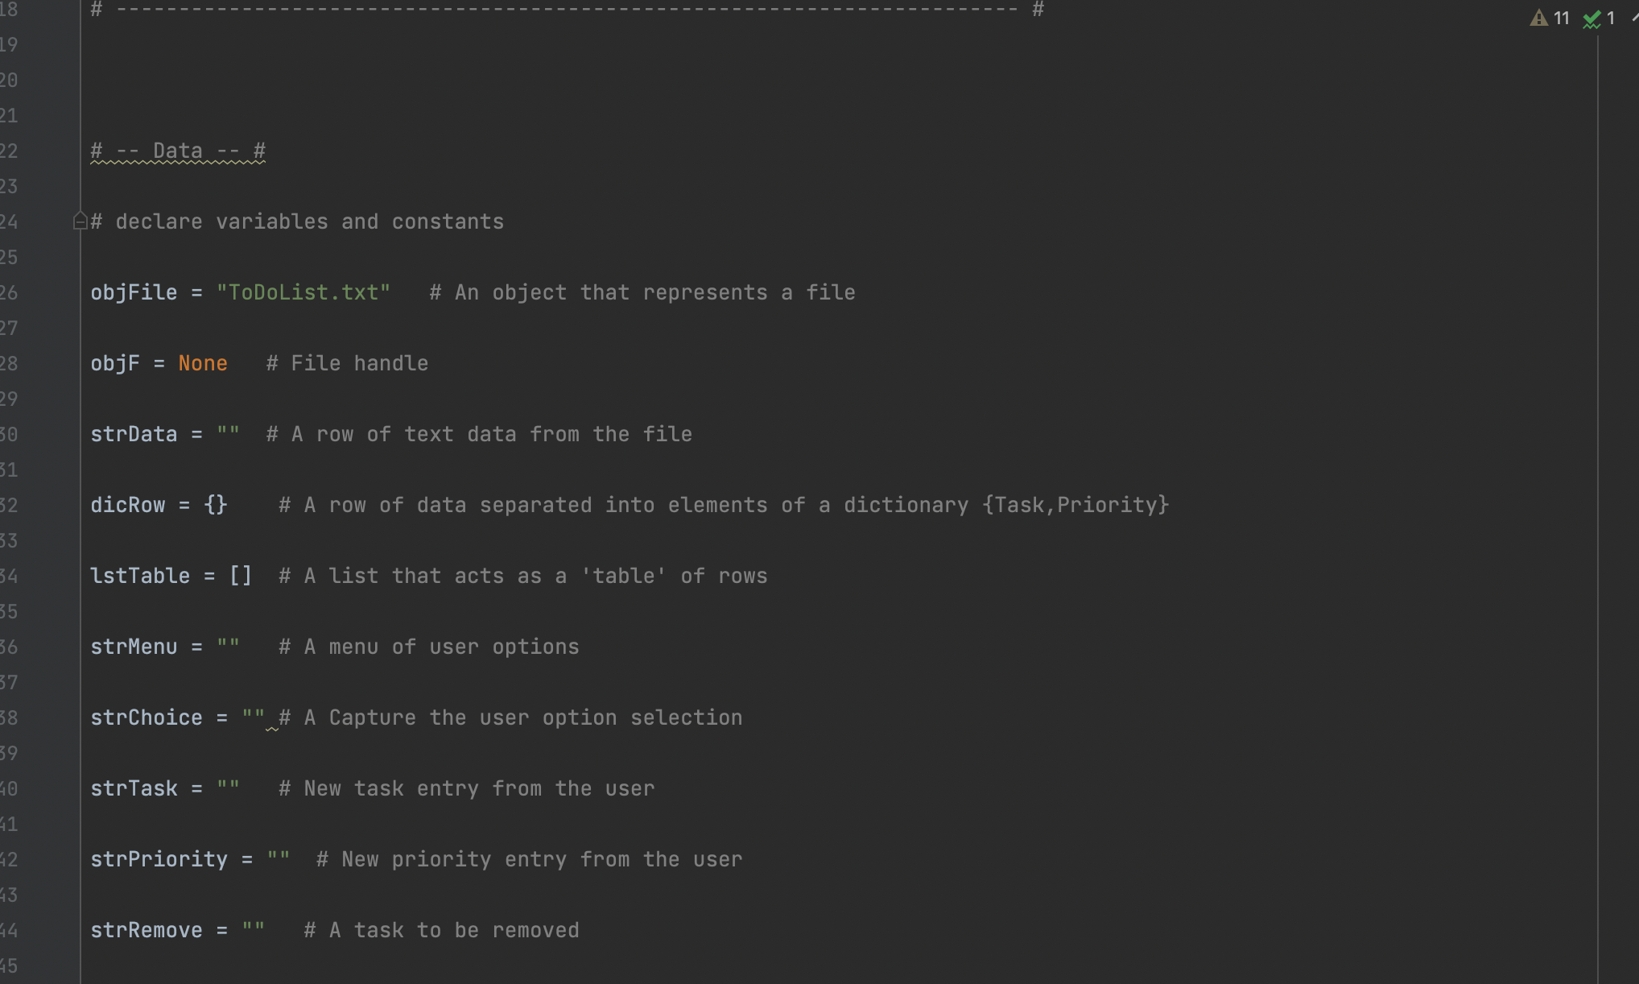

Step #3. I wrote the script that will load the data into a ToDoList.Txt(See fig. 2)

Fig. 2

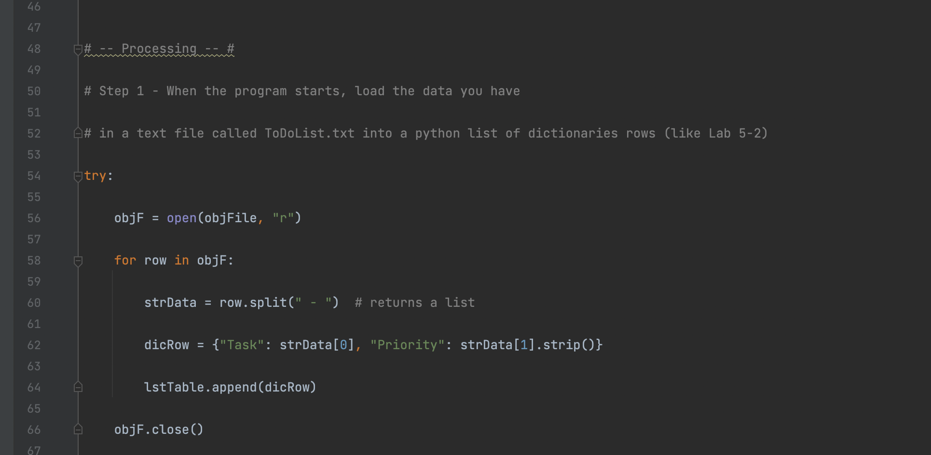

Step #4: I then completed step 2 which will display a menu of choices to the user (see fig. 3)

Fig. 3

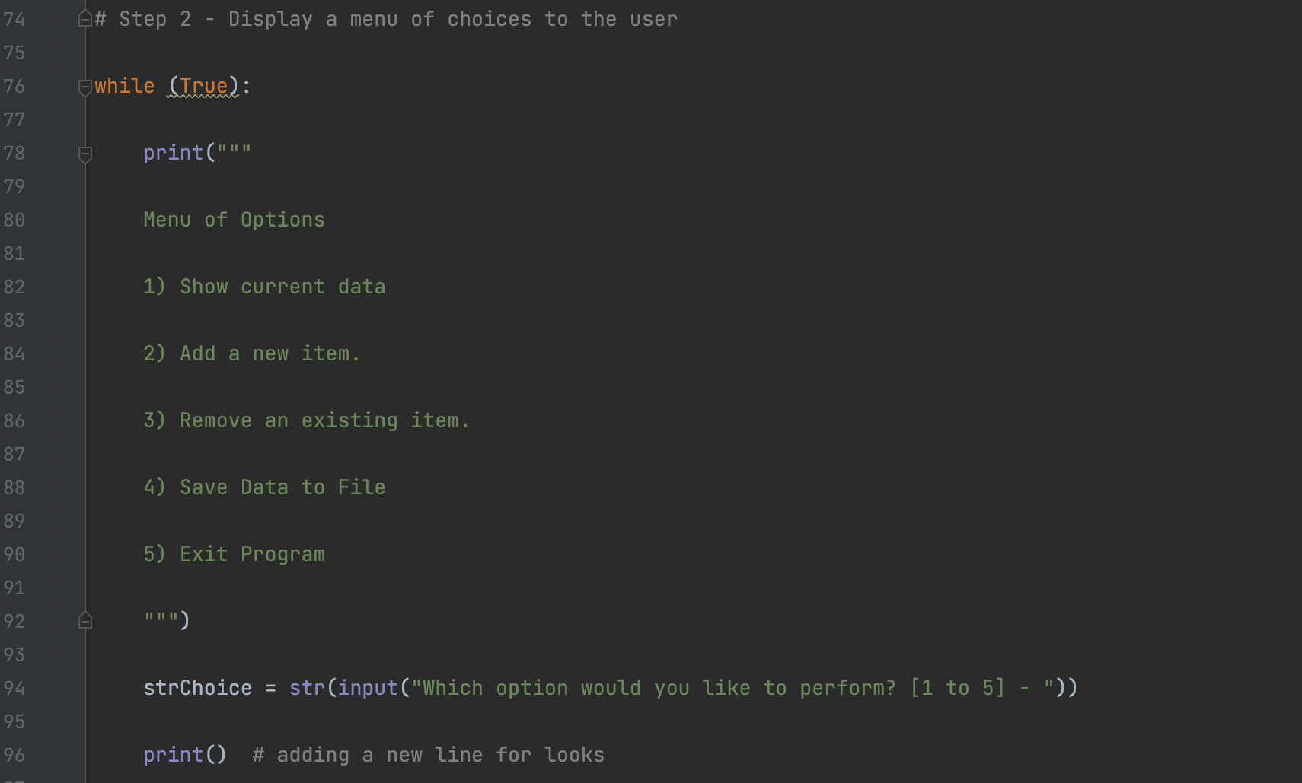

Step #5 I then completed step 3 & 4 which was to allow users to view and select a new item (see fig. 4. I also completed step 5 which was to remove a task (see fig. 5)

Fig. 4

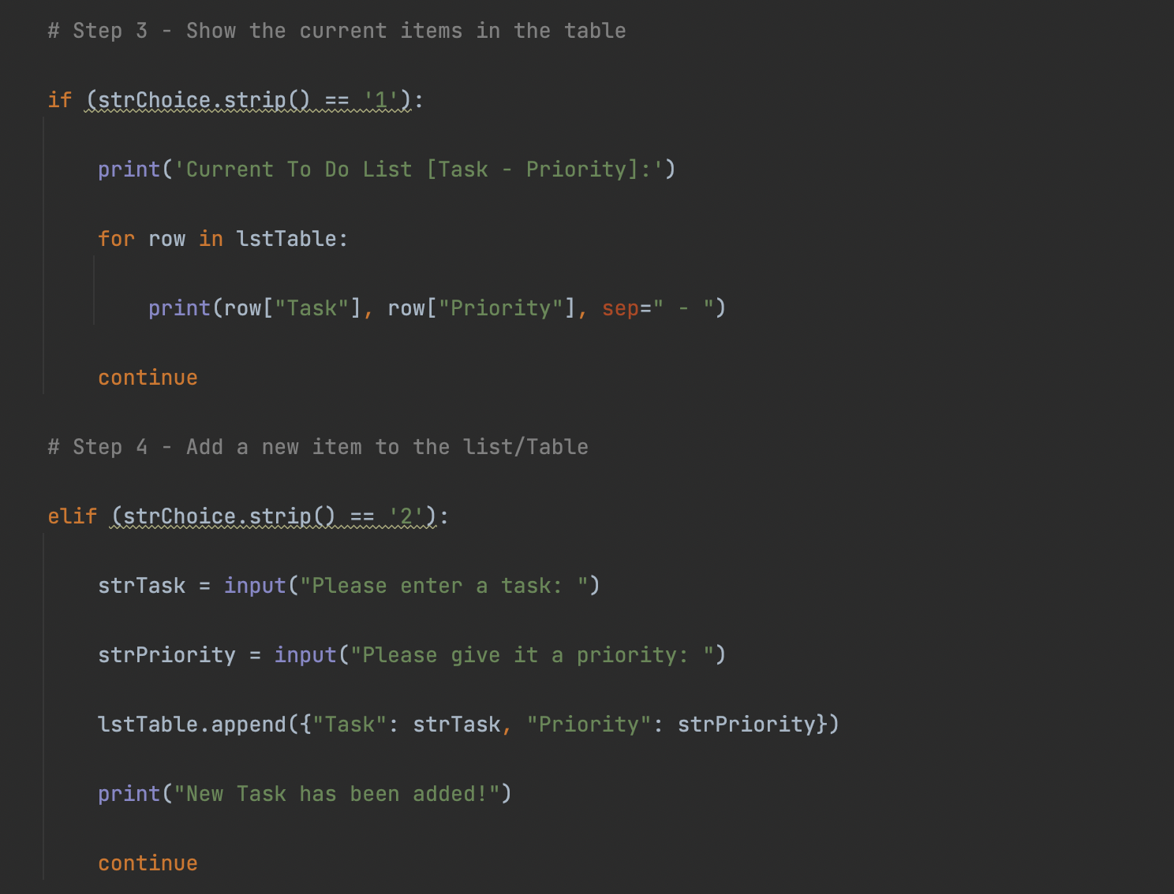

Fig. 5

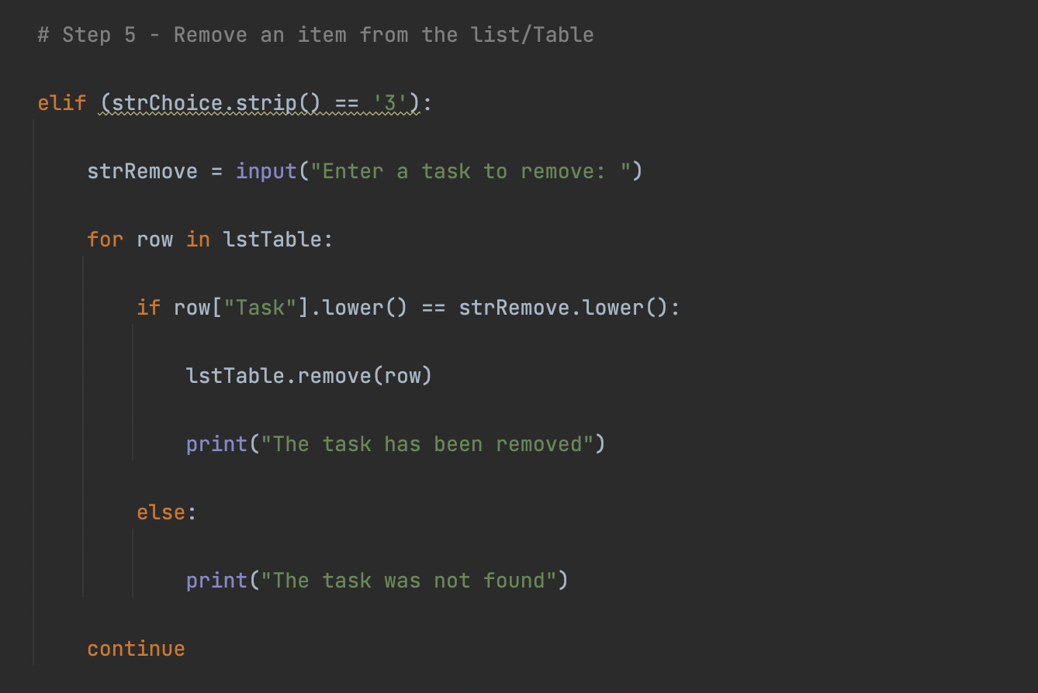

Step #6 The last step of the script was to creat step 6 & 7 which was was to save the task to the .txt file and to exit (see. Fig. 6)

Fig.6

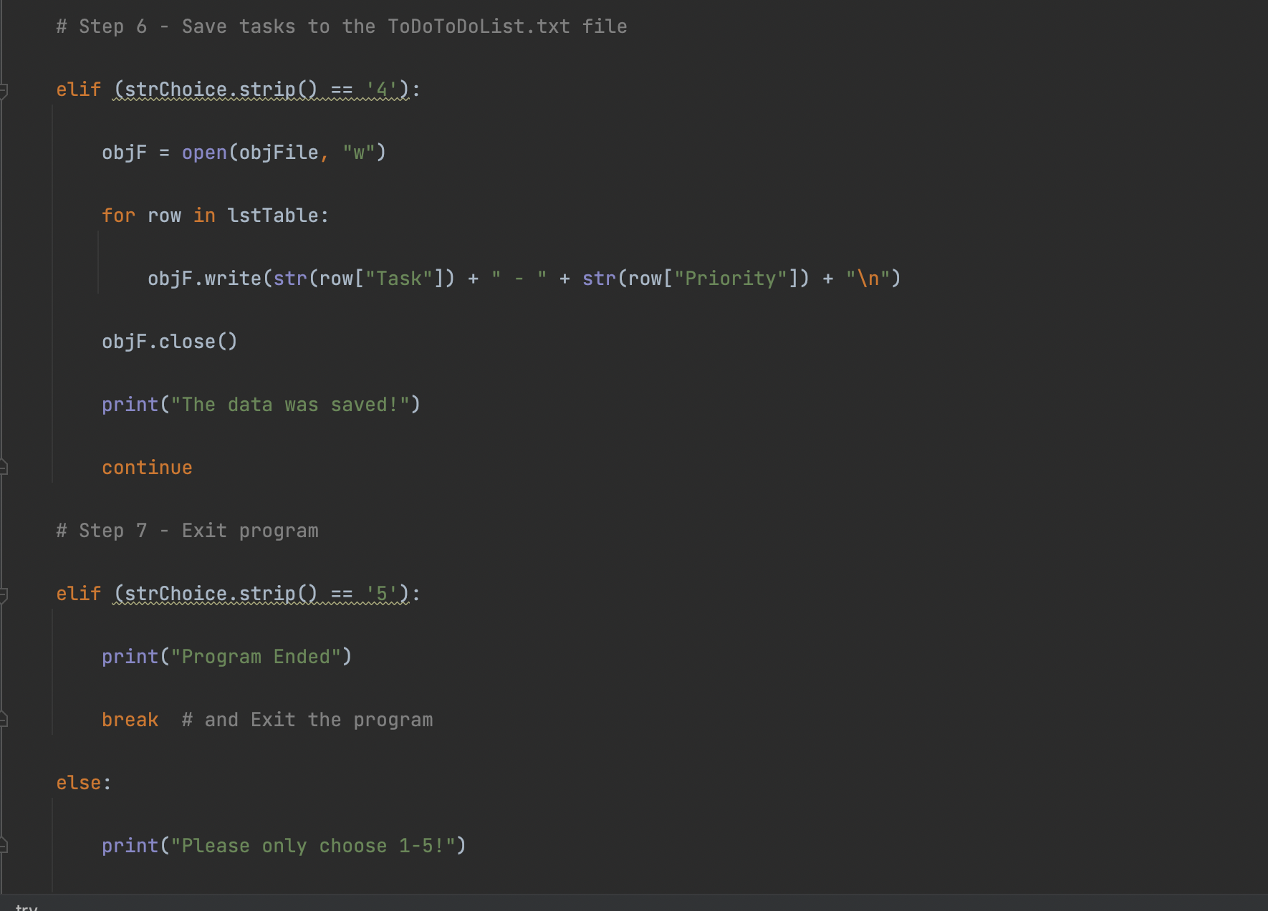

**Summary**

I was able to verify that the script worked because it returned the value when I ran the script. It also saved to the txt file destination that I selected. (see Fig. 7 & Fig. *

Fig. 7

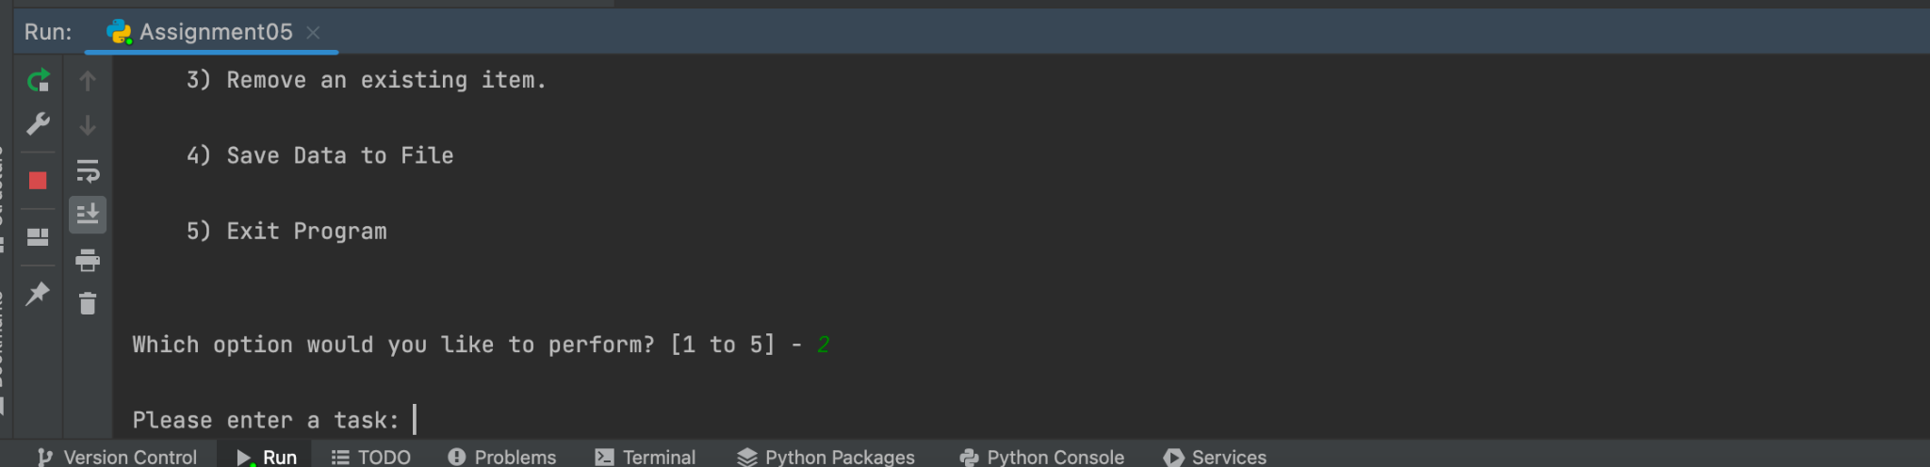

Fig. 8

